NFHS Courses
The student athletes need to login into NFHSlearn.com https://nfhslearn.com/
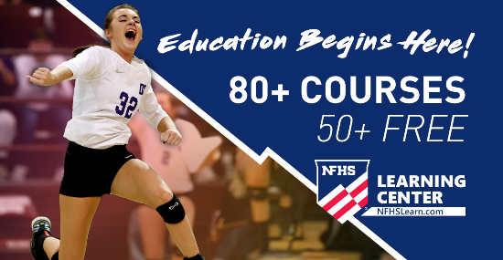 | NFHS Learn | Interscholastic Education, Made Easy  The National Federation of State High School Associations (NFHS) Learning Center is an education tool that offers courses to high school coaches, administrators, officials, students, and parents. It provides a variety of program initiatives that reach the 18,500 high schools and over 11 million students involved in athletic and activity programs.  nfhslearn.com
Create an account,
Look for courses,
- https://nfhslearn.com/courses/concussion-for-students concussion, order the course its free check out as if they are purchasing it and then watch video take picture of completion and upload on athletic clearance.
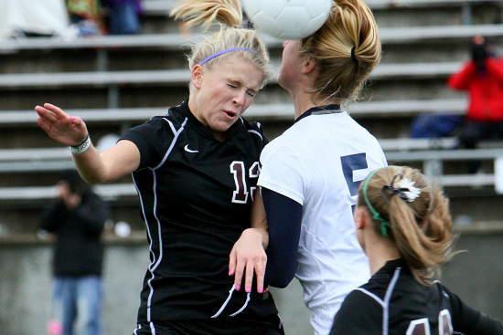 | NFHS Learn | Interscholastic Education, Made Easy  The National Federation of State High School Associations (NFHS) Learning Center is an education tool that offers courses to high school coaches, administrators, officials, students, and parents. It provides a variety of program initiatives that reach the 18,500 high schools and over 11 million students involved in athletic and activity programs.  nfhslearn.com

2. Heat Illness: https://nfhslearn.com/courses/heat-illness-prevention-2
 | NFHS Learn | Interscholastic Education, Made Easy  The National Federation of State High School Associations (NFHS) Learning Center is an education tool that offers courses to high school coaches, administrators, officials, students, and parents. It provides a variety of program initiatives that reach the 18,500 high schools and over 11 million students involved in athletic and activity programs.  nfhslearn.com
3. Sudden Cardiac: https://nfhslearn.com/courses/sudden-cardiac-arrest
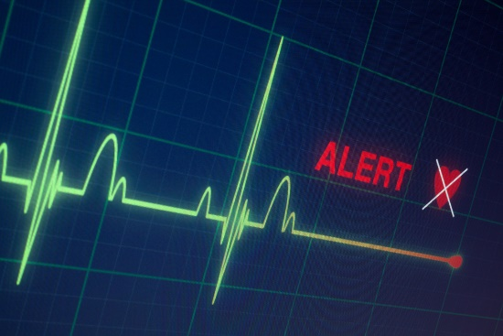 | NFHS Learn | Interscholastic Education, Made Easy  The National Federation of State High School Associations (NFHS) Learning Center is an education tool that offers courses to high school coaches, administrators, officials, students, and parents. It provides a variety of program initiatives that reach the 18,500 high schools and over 11 million students involved in athletic and activity programs.  nfhslearn.com

3. Bully, hazing: https://nfhslearn.com/courses/bullying-hazing-and-inappropriate-behaviors
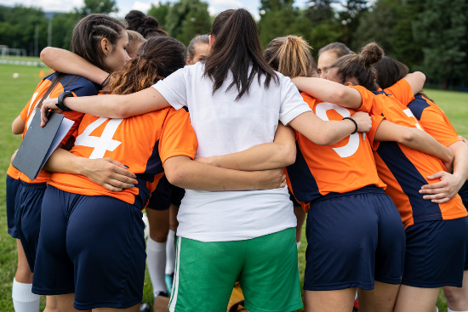 | NFHS Learn | Interscholastic Education, Made Easy  The National Federation of State High School Associations (NFHS) Learning Center is an education tool that offers courses to high school coaches, administrators, officials, students, and parents. It provides a variety of program initiatives that reach the 18,500 high schools and over 11 million students involved in athletic and activity programs.  nfhslearn.com

